**NAGP Angular Assignment**

To fulfil the requirements i.e. to create “**Covid Tracking application**” in angular, various components, services, models are created.

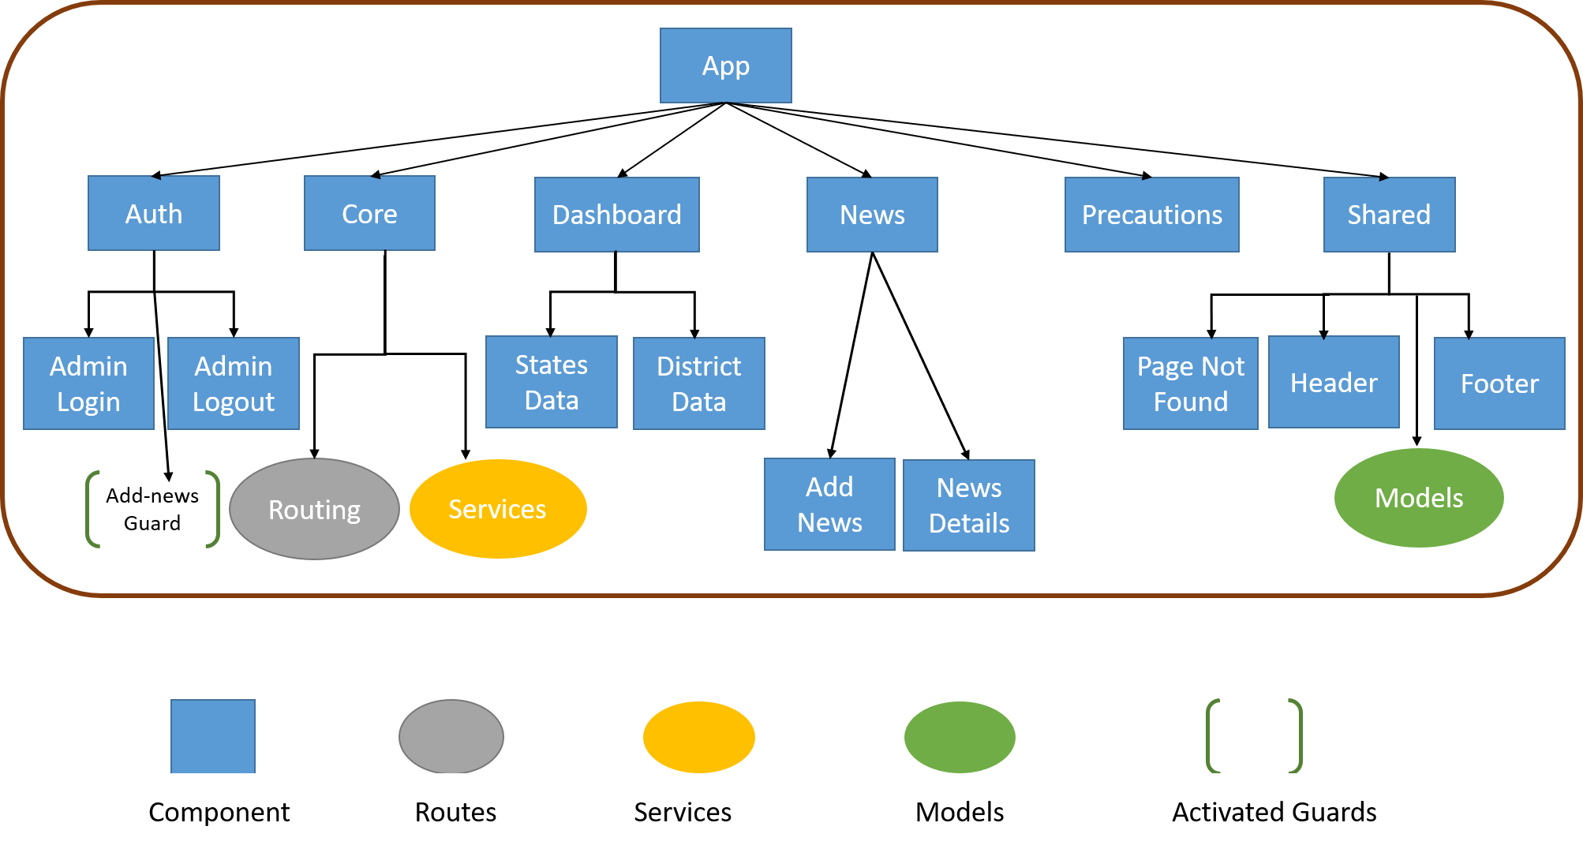

**Figure: Flow of My Covid Tracking Application**

**High level overview of workflow**

Overview of created components, services, guards and modules are given below.

**Main Components**

1. **Auth component** provides all authentication related functionality to admin user.
2. **Core component** includes routing mechanism to switch between pages and provides services to fetch and save data.
3. **Dashboard component** contains details of the states of India and details of all districts of a state.
4. **News component** have the functionality to add latest news and fetch all news posted by admin.
5. **Precautions component** provides all necessary precautions for the user.
6. **Shared component** contains shared features like header/footer of the application, required models.

**Sub-components**

1. **Admin-login component** used to authenticate admin user.
2. **Admin-logout component** used to logout admin user.
3. **States-data component** used to fetch data of India’s states.
4. **District-data component** used to fetch all districts data of a state.
5. **News-add component** used to add latest news by admin. Only admin user can render this component.
6. **News-details component** used to fetch latest news posted by admin.
7. **Page-not-found component** gets load when there is no matching path in the routing module.
8. **Header component** contains application header from which user can navigate to dashboard, news and precautions.
9. **Footer component** is the application footer which contains creator of the application and today’s date.

**Services**

1. **Auth Service** used to fetch and validate user from dummy data and provides login and logout service by adding or removing token from ***local storage***.
2. **Covid-data Service** used to fetch states and districts data from the external APIs using ***http service***.
3. **News-details Service** used to fetch news posted by admin and add latest news in in-memory-data-store using ***in-memory-web-api module*.**
4. **News-in-memory-data Service** implements angular ***InMemoryDBService*** which is used to perform CRUD operations on news.
5. **Precaution Service** used to fetch general precautionary measures for the user from the dummy data.

**Guard(s)**

1. **Add-news-activate Guard** ensures that only logged in user can navigate to add-news route.

**Module(s)**

1. **App-routing module** has all the necessary routes to navigate between the pages and provides router service.

**Unit Testing**

Unit testing was performed for each components, services and modules. According to the requirement, each ***spec.ts*** file contains at least 2 test cases.

|  |  |
| --- | --- |
| Route | Loaded Component |
| '' | Redirects to /dashboard |
| dashboard | Dashboard component |
| dashboard/state/:state | DistrictDataComponent |
| news | NewsComponent |
| news/add | AddNewsComponent |
| precautions | PrecautionsComponent |
| login | AdminLoginComponent |
| logout | AdminLogoutComponent |
| ** | PagenotfoundComponent |

**Table: All used routes in my application**

**Assumptions**

1. Credentials to logged in into the application

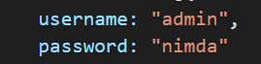

1. **Local Storage** is used to store token and logged in username.
2. **Bootstrap 4** is used for styling the application.
3. **ngx-toastr notification** is used to show success, error and warning message.
4. **In-memory-web-api service** is used for news related information.
5. **HTTPService** is used to fetch Covid-19 data of districts and states of India.

**Git Hub (Link)**

<https://github.com/jagrati-goyal/nagp-covid-tracking-app>

**Deployed Application (Link)**

<http://covid-tracking-app-nagp.surge.sh/>